Octagonal Rotunda
# Source: AI Source: Provided by: [Data Path: Persons Table -> ID Column: 1, Name_En Column: Motasem Essam] -> From: [ChatGPT] on [7/25/2026]
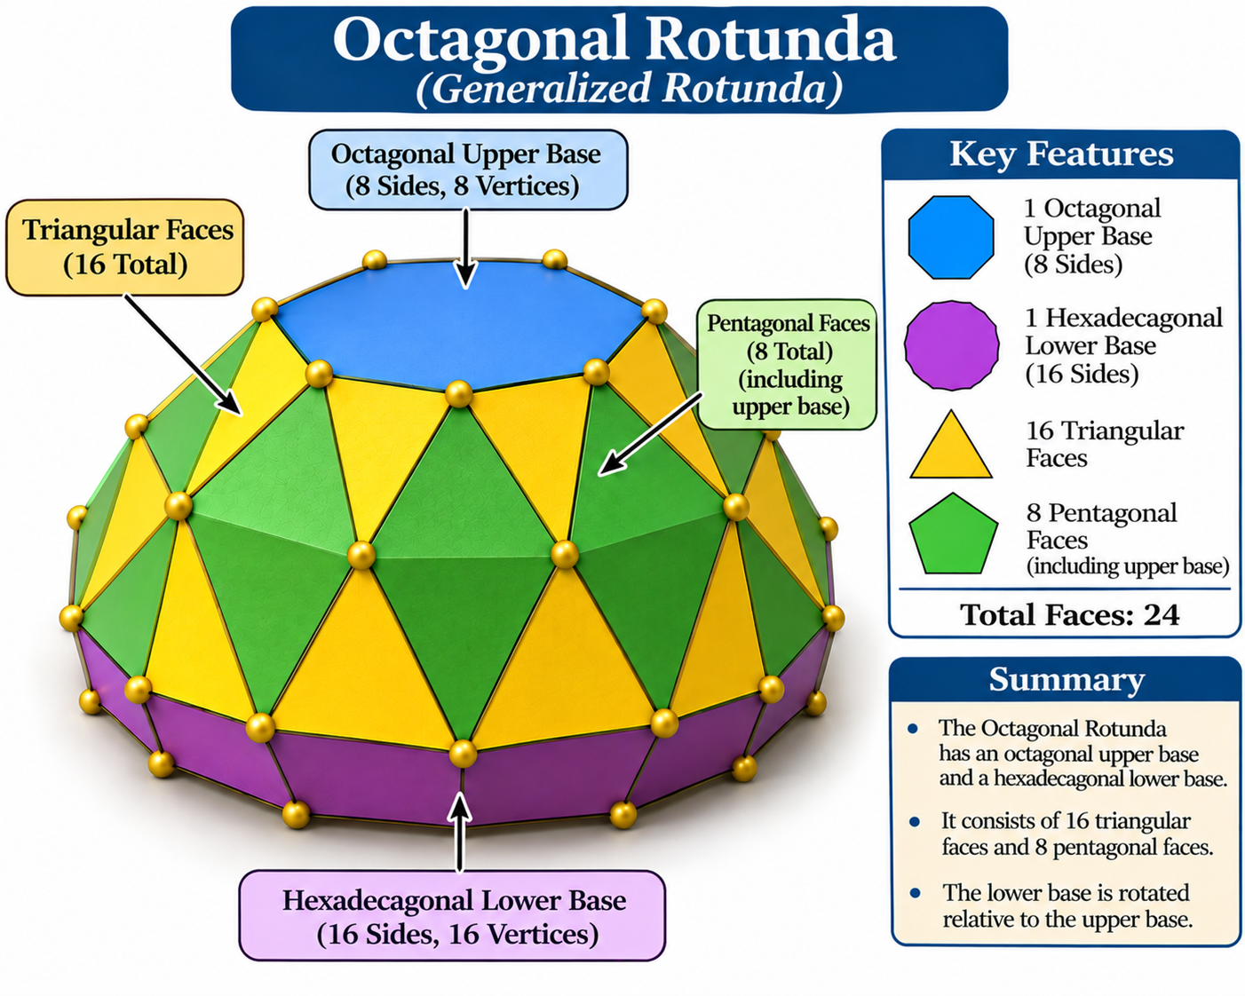

Definition
# Source: AI Source: Provided by: [Data Path: Persons Table -> ID Column: 1, Name_En Column: Motasem Essam] -> From: [ChatGPT] on [7/25/2026]
An Octagonal Rotunda is a generalized rotunda-type polyhedron constructed with an octagonal upper base and a parallel hexadecagonal (16-sided) lower base.
Its lateral surface consists of alternating triangular and pentagonal faces arranged around the solid.
- 1 octagonal upper base.
- 1 hexadecagonal lower base.
- 16 triangular lateral faces.
- 8 pentagonal lateral faces.
It belongs to the generalized rotunda family and is not a classical Johnson solid. The Pentagonal Rotunda is the only classical rotunda whose faces are all regular polygons with equal edge lengths. <Cite refs={["turn802382search0","turn802382search12","turn802382search3"]}/>

Geometric Structure
# Source: AI Source: Provided by: [Data Path: Persons Table -> ID Column: 1, Name_En Column: Motasem Essam] -> From: [ChatGPT] on [7/25/2026]
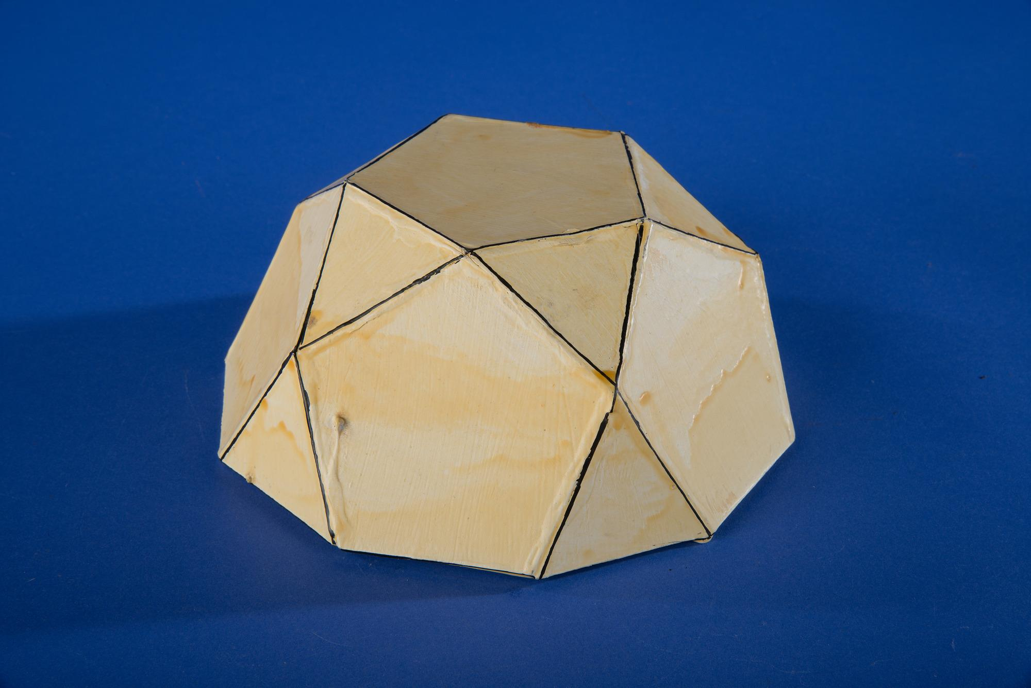
The structure is based on two parallel polygonal bases:
- Upper Base: An octagon with 8 sides.
- Lower Base: A hexadecagon with 16 sides, positioned parallel to the upper base and rotated relative to it.
- Lateral Surface: A band of 24 faces consisting of 16 triangles and 8 pentagons.
The triangular and pentagonal faces alternate around the lateral structure.

Face Composition
# Source: AI Source: Provided by: [Data Path: Persons Table -> ID Column: 1, Name_En Column: Motasem Essam] -> From: [ChatGPT] on [7/25/2026]
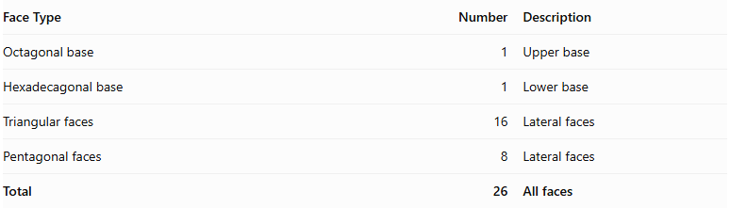
Face Type | Number | Description
Octagonal base | 1 | Upper base
Hexadecagonal base | 1 | Lower base
Triangular faces | 16 | Lateral faces
Pentagonal faces | 8 | Lateral faces
Total | 26 | All faces

Mathematical Properties
# Source: AI Source: Provided by: [Data Path: Persons Table -> ID Column: 1, Name_En Column: Motasem Essam] -> From: [ChatGPT] on [7/25/2026]
For a generalized rotunda with $n=8$:
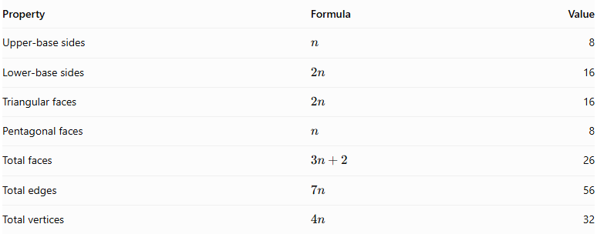
Property | Formula | Value
Upper-base sides | $$n$$ | 8
Lower-base sides | $$2n$$ | 16
Triangular faces | $$2n$$ | 16
Pentagonal faces | $$n$$ | 8
Total faces | $$3n+2$$ | 26
Total edges | $$7n$$ | 56
Total vertices | $$4n$$ | 32
Euler's Polyhedron Formula:
$$V-E+F=2$$
$$32-56+26=2$$
The counts satisfy Euler's formula for a topologically spherical polyhedron. <Cite refs={["turn802382search12","turn802382search2"]}/>

Geometric Characteristics
# Source: AI Source: Provided by: [Data Path: Persons Table -> ID Column: 1, Name_En Column: Motasem Essam] -> From: [ChatGPT] on [7/25/2026]
- Upper Base Shape: Octagon.
- Lower Base Shape: Hexadecagon.
- Lateral Face Types: Triangles and pentagons.
- Total Faces: 26.
- Total Edges: 56.
- Total Vertices: 32.
- Rotational Symmetry: Eightfold rotational symmetry in the symmetric arrangement.
- Convexity and Regularity: These depend on the geometric realization. The generalized construction does not require all faces to be regular or all edges to have equal lengths.

Construction of Octagonal Rotunda

Geometric Instruments Used
# Source: AI Source: Provided by: [Data Path: Persons Table -> ID Column: 1, Name_En Column: Motasem Essam] -> From: [ChatGPT] on [7/25/2026]
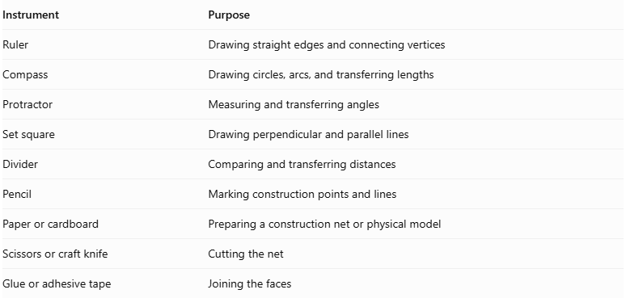
Instrument | Purpose
Ruler | Drawing straight edges and connecting vertices
Compass | Drawing circles, arcs, and transferring lengths
Protractor | Measuring and transferring angles
Set square | Drawing perpendicular and parallel lines
Divider | Comparing and transferring distances
Pencil | Marking construction points and lines
Paper or cardboard | Preparing a construction net or physical model
Scissors or craft knife | Cutting the net
Glue or adhesive tape | Joining the faces

Instrument-Based Construction Procedures
# Source: AI Source: Provided by: [Data Path: Persons Table -> ID Column: 1, Name_En Column: Motasem Essam] -> From: [ChatGPT] on [7/25/2026]
No coordinate-based construction
The construction uses geometric instruments, polygon geometry, measured lengths, angles, and face-to-face edge matching. It does not use coordinate axes, coordinate points, or coordinate equations.

Construct the Upper Regular Octagonal Base
# Source: AI Source: Provided by: [Data Path: Persons Table -> ID Column: 1, Name_En Column: Motasem Essam] -> From: [ChatGPT] on [7/25/2026]
- Draw a circle using a compass.
- Construct two perpendicular diameters through its center.
- Bisect the four central right angles to obtain eight equally spaced points on the circumference.
- Join consecutive points using a ruler.
- Verify that the resulting regular octagon has eight equal sides.
- Label the vertices $A,B,C,D,E,F,G,H$.
A regular octagon can be constructed exactly using a compass and straightedge.

Construct the Lower Regular Hexadecagonal Base
# Source: AI Source: Provided by: [Data Path: Persons Table -> ID Column: 1, Name_En Column: Motasem Essam] -> From: [ChatGPT] on [7/25/2026]
- Draw a second circle using a compass.
- Construct a regular octagon inscribed in the circle.
- Bisect each of the eight central angles between consecutive octagon vertices.
- Mark the eight additional points on the circumference.
- Join all sixteen consecutive points using a ruler.
- Verify that the resulting regular hexadecagon has sixteen equal sides.
- Label the vertices $P_{1},P_{2},…,P_{16}$.
A regular hexadecagon can also be constructed exactly using a compass and straightedge.

Construct the Sixteen Triangular Lateral Faces
# Source: AI Source: Provided by: [Data Path: Persons Table -> ID Column: 1, Name_En Column: Motasem Essam] -> From: [ChatGPT] on [7/25/2026]
- Prepare sixteen triangular faces using a ruler, compass, and protractor.
- Determine their side lengths and angles from the selected Octagonal Rotunda model.
- Arrange the triangles according to the intended lateral face pattern.
- Match their edges to the corresponding edges of the pentagonal faces and bases.
- Verify that each triangle fits its neighboring faces without gaps or unintended overlaps.

Construct the Eight Pentagonal Lateral Faces
# Source: AI Source: Provided by: [Data Path: Persons Table -> ID Column: 1, Name_En Column: Motasem Essam] -> From: [ChatGPT] on [7/25/2026]
- Prepare eight pentagonal faces.
- Determine their side lengths and interior angles from the selected model.
- Arrange the pentagons alternately within the lateral face arrangement.
- Match their edges with the appropriate neighboring triangular faces.
- Verify that the eight pentagons complete the lateral structure correctly.

Arrange the Faces
# Source: AI Source: Provided by: [Data Path: Persons Table -> ID Column: 1, Name_En Column: Motasem Essam] -> From: [ChatGPT] on [7/25/2026]
- Position the regular octagonal upper base and regular hexadecagonal lower base parallel to each other.
- Arrange the sixteen triangles and eight pentagons between the two bases.
- Check the lengths of all shared edges.
- Verify the intended eightfold rotational arrangement.
- Confirm that every edge belongs to exactly two faces and that the surface closes without gaps or overlaps.

Assemble the Solid
# Source: AI Source: Provided by: [Data Path: Persons Table -> ID Column: 1, Name_En Column: Motasem Essam] -> From: [ChatGPT] on [7/25/2026]
- Prepare a verified construction net or separate face pieces with the correct adjacency arrangement.
- Add joining tabs if using paper or cardboard.
- Cut out the faces.
- Fold the required edges if using a net.
- Join the matching lateral faces.
- Attach the upper octagonal base and lower hexadecagonal base.
- Inspect the completed model from several directions.
Construction accuracy: The eight pentagons and sixteen triangles must have dimensions and angles compatible with the selected generalized model. Simply using eight regular pentagons, sixteen equilateral triangles, a regular octagon, and a regular hexadecagon does not guarantee a valid closed Octagonal Rotunda. The face geometry and adjacency must be verified before assembly.

Key Points
# Source: AI Source: Provided by: [Data Path: Persons Table -> ID Column: 1, Name_En Column: Motasem Essam] -> From: [ChatGPT] on [7/25/2026]
- The Octagonal Rotunda has an 8-sided upper base and a 16-sided lower base.
- Its lateral surface contains 16 triangles and 8 pentagons.
- It has 26 faces, 56 edges, and 32 vertices.
- It is a generalized rotunda, not a classical Johnson solid.
- Its construction follows the same general face arrangement as other rotundas.

Main Classification
# Source: AI Source: Provided by: [Data Path: Persons Table -> ID Column: 1, Name_En Column: Motasem Essam] -> From: [ChatGPT] on [7/25/2026]
Solid Geometry
└── Types of Solids
└── Rotunda
└── Types of Rotundas
└── Octagonal Rotunda
├── Octagonal Upper Base
├── Hexadecagonal Lower Base
├── Triangular Lateral Faces
└── Pentagonal Lateral Faces

Conclusion
# Source: AI Source: Provided by: [Data Path: Persons Table -> ID Column: 1, Name_En Column: Motasem Essam] -> From: [ChatGPT] on [7/25/2026]
The Octagonal Rotunda is a generalized rotunda-type polyhedron with an octagonal upper base, a hexadecagonal lower base, and an alternating arrangement of triangular and pentagonal lateral faces. It has 26 faces, 56 edges, and 32 vertices.

